

INDEPENDENT UNIVERSITY BANGLADESH

**SUMMER 2023**

**WEBSITE PROPOSAL**

**Website Title: Advanced Parking**

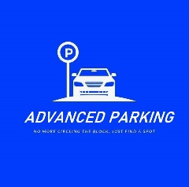

**Submitted to:**  
 **Mr. Sanzar Adnan Alam**

**Lecturer**

**Department of Computer Science and Engineering**

**Members:**

**1. S.M Farhan Shariar (1920408)**

**2. Asifur Rahman Shikdar (1921770)**

**3. Mumit Ibna Idris (1930785)**

**SUBMISSION DATE: 25 August 2023**

Table of Contents

Introduction 3

* Project Objectives………………………………………………………………………………………….3

Section 1 – Initial Development 3-4

Section 2 – Proposed Website Structure 4

Section 2 – Data Flow Diagram 5

Section 2 – Rich Picture 6

Website Structure Flowchart Details 7

* Proposed Website Structure (Front-End) ………………………………………………………………7

Optional Add-ins …………………………………………………………………...7

* Proposed Website Structure (Back End). ………………………………………………………………8

Section 3 - Functionality 8

***Introduction***

Finding a parking space has become time-consuming everywhere due to the increase in automobile traffic. All the parking thronged with the cars leaving the car driver to dismay. We have developed a solution to aid car drivers with this issue by giving them access to the car parking finger mobile app and website. that guide them directly to available spots where they can park their cars. We are Using HTML, CSS & Java Script to build this website

**Key Feature:**

1. User friendly apps & website design
2. Partnership with shopping malls this will help users to see parking slots available in the certain shopping mall
3. In app & website payment option user can pay for parking fees through the app
4. Location free parking space on the street
5. Proper information of the parking style-parallel parking vs Side ways

**Section 1:Initial Development**

**W Website Development Process:**

Our inspiration for creating the website came from the difficulty people have finding a suitable parking spot in our city. To address this issue, we introduce our website & Application. Building this website we Using HTML,CSS & PHP. This Website will display available free parking spots as well as spots where the garage owner will update parking spots

**Project Goal & Objective**

The primary goal of our project is to create a website and application that will enable users to view parking options in a location before traveling there; doing so would undoubtedly save the driver's time and trouble when looking for a parking space.

**History Leading to Project:**

Our inspiration for creating the app and website came from the difficulty people have finding a suitable parking spot in our city. To address this issue, we introduce our website, which will display available free parking spots as well as spots where the garage owner will update parking spots.

**Section 1:Proposal Website Structure**

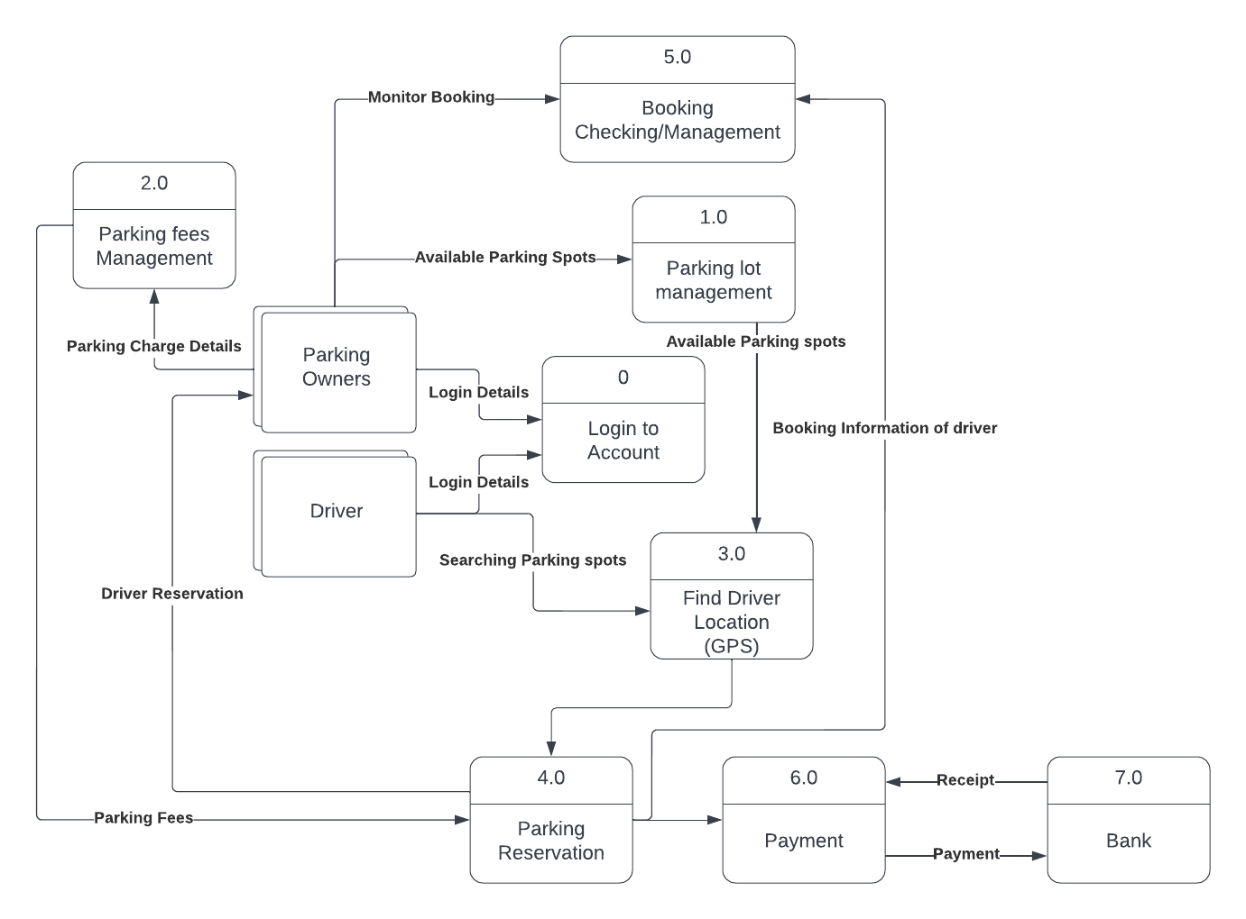

**Data Flow Diagram:**

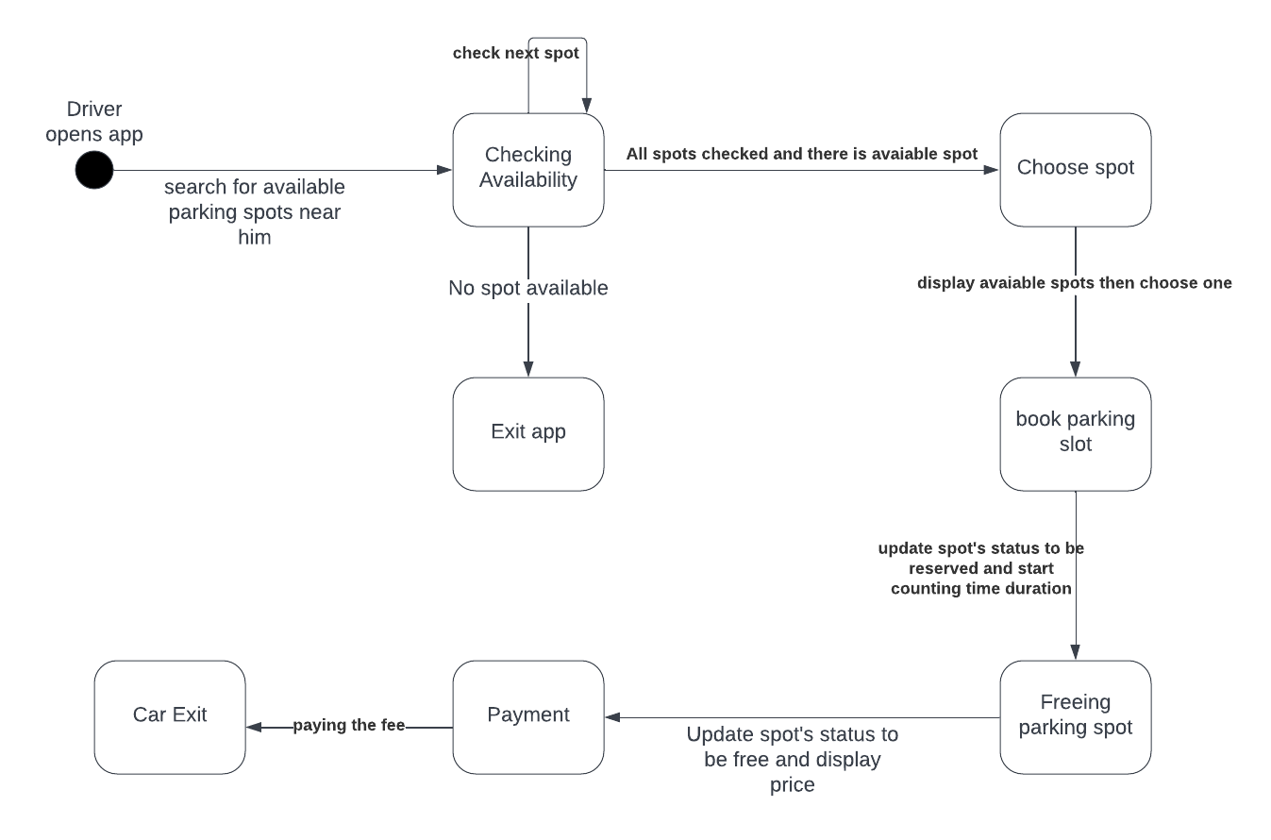

**Activity Diagram:**

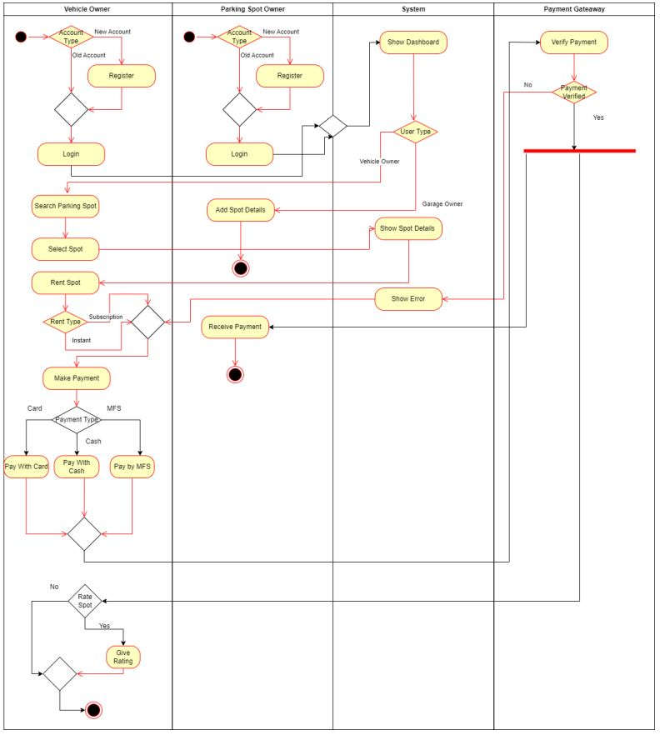

***WebSite Detalis:***

***Front-End***

**Login Page:** The site will be developed using either frames structure or tables using server side includes. In this Page there two users options.one is for admin and other one is for user both of these give there are name and password to login. For those who hadn’t there user id they go to register page

**Register Page:** In register page there are option for new user to register. In this there are personal information section in this section there are Name, Email and Phone Number Text filed and also register button

**Admin Pannel:** Admin user use this page in this page there are a dashboard where total parking, total parking slots and user will be shown and there also a box where message will be shown. In this there are separate navbar where there different option will be shown

**Contact Us Page**: In Contract Us page If driver had any message to send they can send message in this page there are text filed of name, email, message and also a submit button

**Home Page**: The home page would consist of some general introductory information about Advance Parking. In this website every page we see a navbar from clicking we can go to this page. In home page there are three option of request parking, Monthly parking and payment

**Find Parking Page**: In find parking there are many option of places where customer are wanted to go. Clicking Bashundhara button we go to the Bashundhara page. In Bashundhara page there are three places show user can select any of those

**List Your Parking Page:** In this page there will be form and by fill up this form driver can register for parking

## *Proposed Website Structure (Back End)*

**Driver & Parking Owner:** Driver and Parking owner is the heart of the back-end access to the virtual community. Available only through secure login, In register page both driver and parking owner can register this data are go into the database. In contract us page driver give feedback this data go into the database. After getting notification from parking owner driver book the spot that how many spot are they need those data are also go to database

**VCSC Database:** All information submitted and received goes through a database housed on the same server that serves the community website. By employing the VCSC database (either Microsoft Access or SQL Server), the portal is constantly dynamic, changing by the moment as citizens interact with the community and other citizens. A variety of data facilities will also be made available through the back-end to allow the Information Services (IS) Manager to compact and repair the database from time to time and to manage the database itself.

**Functionality**

* Note: Reports have not been defined, and are intentionally left out of the development proposal until such time as VCTS has an opportunity to review the data model in more detail. Upon review, CADC will make recommendations for possible reporting and provide NorthSeas with an addendum or new contract for additional development as requested by the client. In the interim, feedback and requests will be handled by email CGI.

**Product**

**Add**

**Edit**

**Delete**

1. This is Website user-friendly layout

2. Forming partnerships with retail centers will enable customers to view parking spaces that are available in that specific center.

3. This website payment option lets users pay parking fines directly from the app.

4. Find a spot to park for free on the street

5. Appropriate information regarding parking techniques: parallel versus side-by-side